Grade Reporting, WPE
-- Every student on your roster must be issued a final grade. --

Complete these steps in order to officially submit your grades:
- First, log into Ocean Connect. Select Self Service for Faculty and Staff.

- In Self Service click “Faculty.”
- From the faculty screen, select the correct section.
- Then navigate to Grading >> Final Grade
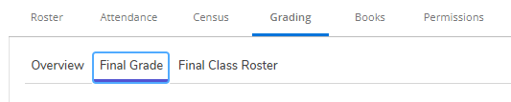
- Using the drop-down list, choose the grades for each student that corresponds to their grade per the syllabus.

Sample Explanations:
- Students who did not attend and did not withdraw still need a final grade. They should have a check mark next to “Never Attended” and they should be awarded a final grade of “NS.”
  - The Never Attended button will be available and if you didn’t check it off when your Final Class List was submitted, you can check it off now, while submitting your final grades.
- If the student failed the class, they should be awarded an “NS” and the Last Day of Attendance should be the final day of the semester.

- Verify that your grades are correct. Once every student has a grade, and you’ve looked it over for accuracy, select “Post Grades” in the upper right corner. Once submitted, these grades cannot be changed via Self-Service. If you feel you may have submitted a grade in error, contact Gerald Mangino at gmangino@ocean.edu. You cannot change verified grades online.

- If you have a student in your class who is not listed on this roster, the student was either dropped or withdrawn. Contact Chris Brittain with questions about these students. Email Christopher_brittain@ocean.edu or call 732-255-0400 x2549.
- Once grading is completed for all sections you are teaching, log out.
Grades should be submitted as soon as possible after the conclusion of the course. The final deadline for grade submission is the final day of your course. Your cooperation with this deadline is essential, and much appreciated!
** Submitted grades should match the letter/numerical grade equivalent from your syllabus**
Grade | Grade Interpretation
S | Satisfactory (Student Passed the Class)
NS | Not Satisfactory (Student Did Not Pass the Class)

