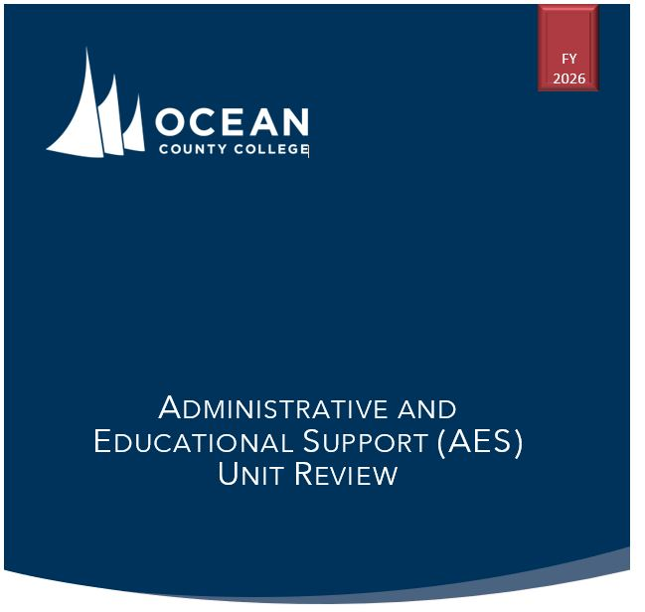

[UNIT NAME]
Unit Review committee:
Team member name
team member name
team member name


CONTENTS

- Unit Summary 1
History of the Unit 1
Organizational Chart 2
- Mission and Goals 3
Linking to the Strategic Plan 3
III. Programs and Services 4
IV. Organizational Effectiveness 5
Demand and Prioritization 5
Digital Services 5
Collaboration 5
Communication 5
Planning, Policy, and Procedure 5
V. Planning and Institutional Improvement 6
Unit Goal 1 6
Unit Goal 2 6
Unit Goal 3 6
Unit Goal 4 6
VI. Financial Resources 7
Budget Analysis 7
Budgeting Needs 7
VII. Future Plans 8
Potential Changes and Trends 8
Appendix A 8

Unit Summary
[This Section should be a maximum of 2 pages including the organizational chart.]
This section should describe succinctly the essential organization, staffing, and operations of the department.

History of the Unit
Individuals outside the unit will be reviewing the documents and will be unaware of conditions that have impacted the unit over time. Provide information describing the history of the unit over the past five years that will provide a context for the review.

Organizational Chart
Insert an Organizational Chart.
For larger space - See Appendix A.

Mission and Goals
[This section should be a maximum of 2 pages]
Unit Mission:

 | Unit Goals | Connection to OCC Strategic Goals and Objectives
1
2
3
4
5

Linking to the Strategic Plan
Optional. If the unit contributes to any Strategic Plan KPIs, Objective Measures, or initiatives they should be noted briefly.
III. Programs and Services
Describe the primary functions and services provided by this unit, organizing them into major categories. For each service, note the links to the unit goals. The focus of this section is to state and describe the services. (Determine are there services to support goals or any goals that need program support)
Things to Consider:
- Are services appropriately organized by major category?
- Are the programs and services appropriate for unit Mission and Goals?
- Are all goals supported by a program or services?
- Are all programs and services linked to goals?
Category Name | Unit Goal(s)
Function/Service – Description
Function/Service – Description
Category Name | Unit Goal(s)
Function/Service – Description
Function/Service – Description
Category Name | Unit Goal(s)
Function/Service – Description
Function/Service – Description
Category Name | Unit Goal(s)
Function/Service – Description
Function/Service – Description
Category Name | Unit Goal(s)
Function/Service – Description
Function/Service – Description

IV. Organizational Effectiveness
[This section should be a maximum of 2 pages]

Demand and Prioritization
Referring to the table above, how does the school prioritize what to pursue within the major categories if resources are limited. For example, what events to hold, professional development to offer, partnerships
to pursue, programs to prioritize for experiential learning or credentials.

Digital Services
Describe how the primary functions and services provided by this unit are made available digitally to distance learning students and/or the campus community. Describe any recommendations for improvement.

Collaboration
What are the key dependencies or critical partners of the unit? What other areas, inside or outside the college, does the unit depend on to provide services to the college, and to what extent, if any, do these dependencies limit the unit's effectiveness?

Communication
How does the unit communicate innovative programs, services, and initiatives within the unit, with key dependencies/critical partners, and with the greater college community?

Planning, Policy, and Procedure
Describe the planning process used by the unit in completing the PBC document and developing objectives for the year. Describe the process the unit has in place to review unit policies and procedures to ensure they are current and available.

V. Planning and Institutional Improvement
Unit Goal 1:
In the context of this Unit Goal, discuss any key accomplishments, successes, or progress made since the last unit review. This should include past PBC objectives. [Max 200 words]

Identify any short-term and long-term objectives that could be tied to this goal over the next review cycle. Use a Bulleted list – one to five objectives.

Unit Goal 2:
In the context of this Unit Goal, discuss any key accomplishments, successes, or progress made since the last unit review. This should include past PBC objectives. [Max 200 words]

Identify any short-term and long-term objectives that could be tied to this goal over the next review cycle. Use a Bulleted list – one to five objectives.

Unit Goal 3:
In the context of this Unit Goal, discuss any key accomplishments, successes, or progress made since the last unit review. This should include past PBC objectives. [Max 200 words]

Identify any short-term and long-term objectives that could be tied to this goal over the next review cycle. Use a Bulleted list – one to five objectives.

Unit Goal 4:
In the context of this Unit Goal, discuss any key accomplishments, successes, or progress made since the last unit review. This should include past PBC objectives. [Max 200 words]

Identify any short-term and long-term objectives that could be tied to this goal over the next review cycle. Use a Bulleted list – one to five objectives.

VI. Financial Resources
[This section should be a maximum of 2 pages]

Budget Analysis
Analyze the unit’s budgeted and actual expenses over the past three years. Briefly explain key takeaways such as causes of budget deficits or trends in expenditures. When examining budget lines, are there specific lines that have been underspent or underfunded?

Describe what similar units at peer or benchmark institutions are doing that this unit would like to do or could be doing?

Budgeting Needs
What are the greatest resource needs for the unit? These needs must be supported by evidence and data and the data must be included in this document. (No more than three) If the unit gained these additional resources, what would the expected outcomes be? Be specific and provide expected timelines, rationale, and data as appropriate. It is recommended that these needs be reflected in future PBC documents, supported by evidence and data.

VII. Future Plans
[This section should be a maximum of 2 pages including Opportunities chart]

Potential Changes and Trends
Are there specific ways you are planning for your unit to evolve (e.g., new/discontinuation of services, changes in operational strategies) in the next 5 years? If so, what are you planning? Why is this change necessary?
As you think about factors external to your unit (at OCC, in your field, or nationally), are there emerging trends that will significantly impact your unit? How do you plan to respond?

Appendix A: Org Chart
___________________________________________ _________________
[Signature of VP] [Date]

Sara Winchester
Executive Vice President of Finance and Administration
___________________________________________ _________________
[Signature of President] [Date]

Pamela J. Monaco, Ph.D.
College President

